Walmart Sales Analysis

About Data

The datasets contains sales transactions from a three different branches of Walmart, respectively located in Mandalay, Yongon and Naypyitaw. The data contains 17 columns and 1000 rows.

|  |  |  |
| --- | --- | --- |
| Columns | Description | Data Types |
| Invoice_id | Invoice of the sales made | VARCHAR(30) |
| Branch | Branch at which sale were made | VARCHAR(5) |
| City | The location of the branch | VARCHAR(30) |
| Customer_type | The type of the Customer | VARCHAR(30) |
| Gender | Gender of the customer making purchase | VARCHAR(10) |
| Product_line | Product line of the Product solf | VARCHAR(100) |
| Unit_price | The price of each Product | DECIMAL(10,2) |
| Quantity | The amount of product sold | INT |
| VAT | The amount of tax on the purchase | FLOAT(6,4) |
| Total | The Total cost of the purchase | DECIMAL(10,2) |
| Date | The date on which the purchase was made | DATE |
| Time | The time at which the purchase was made | TIMESTAMP |
| Payment_method | The Payment modes | VARCHAR(30) |
| Cogs | Cost of Goods sold | DECIMAL(10,2) |
| Gross_margin_Percentage | Gross margin percentage | FLOAT(11,9) |
| Gross_income | Gross income | DECIMAL(10,2) |
| Rating | Rating | FLOAT(2,1) |

**Required Analysis**

**Product Analysis:**

Conduct analysis on the data to understand the different product lines, identify the best-performing product lines, and determine which product lines need improvement.

**Sales Analysis:**

This analysis aims to answer questions about sales trends of products. The results can help measure the effectiveness of each sales strategy the business applies and identify necessary modifications to increase sales.

**Customer Analysis:**

This analysis aims to uncover different customer segments, purchase trends, and the profitability of each customer segment.

Adding the columns

1. time_of_day (Morning, Afternoon, Evening)

UPDATE sales

SET

time_of_day = (CASE

WHEN `time` BETWEEN '00:00:00' AND '12:00:00' THEN 'Morning'

WHEN `time` BETWEEN '12:01:00' AND '16:00:00' THEN 'Afternoon'

ELSE 'Evening'

END);

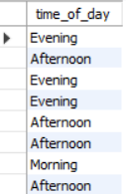

1. day_name (Sunday, Monday, Tuesday … )

UPDATE sales

SET

day_name = DAYNAME(`date`);

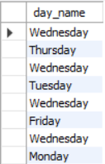

1. month_name (January, February, March, April …)

UPDATE sales

SET

`Month` = MONTHNAME(`date`);

ALTER TABLE sales

RENAME COLUMN `Month` to month_name;

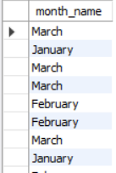

Business Questions to Answer

# Generic question

Q) How many unique cities does the data have ?

SELECT

COUNT(DISTINCT city) AS unique_city_count

FROM

sales;



Q) In which city is each branch ?

SELECT

DISTINCT City, branch

FROM

sales;

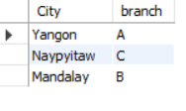

# Product Questions

Q) How many unique product lines does the data have ?

SELECT

COUNT(DISTINCT product_line) AS unique_product_line_count

FROM

sales;



Q) What is the Most Common Payment method ?

SELECT

payment_method, COUNT(payment_method) AS use_method

FROM

sales

GROUP BY payment_method

ORDER BY use_method DESC

LIMIT 1;

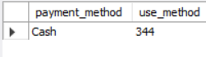

Q) Which is the most selling product line ?

SELECT

product_line, MAX(total) AS max_sales

FROM

sales

GROUP BY product_line

ORDER BY max_sales DESC

LIMIT 1;



Q) What is the Total Revenue by Month ?

SELECT

month_name, SUM(total) AS Total_Revenue

FROM

sales

GROUP BY month_name

ORDER BY Total_Revenue DESC;

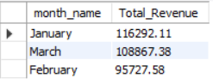

Q) Which month had the largest COGS ?

SELECT

month_name, SUM(cogs) AS COGS

FROM

sales

GROUP BY month_name

ORDER BY COGS DESC;

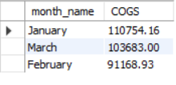

Q) Which product line had the largest revenue ?

SELECT

product_line, SUM(total) AS Total_rev

FROM

sales

GROUP BY product_line

ORDER BY Total_rev DESC

LIMIT 1;

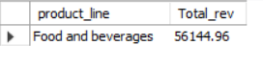

Q) Which is the city with Maximum Revenue ?

SELECT

city, SUM(total) AS Max_Rev

FROM

sales

GROUP BY city

ORDER BY Max_Rev DESC

LIMIT 1;

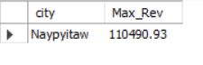

Q) Which Product line had largest VAT ?

SELECT

product_line, SUM(VAT) AS Max_VAT

FROM

sales

GROUP BY product_line

ORDER BY Max_VAT DESC

LIMIT 1;

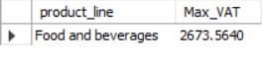

Q) Which branch sold more than average product sold ?

SELECT

branch, SUM(quantity) AS Total_sold_product

FROM

sales

GROUP BY branch

HAVING SUM(quantity) > (SELECT

AVG(quantity)

FROM

sales)

ORDER BY Total_sold_product DESC

LIMIT 1;

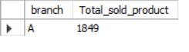

Q) What is the most common product line by gender ?

SELECT

gender, product_line, COUNT(gender) AS Gender_count

FROM

sales

GROUP BY gender , product_line

ORDER BY Gender_count DESC;

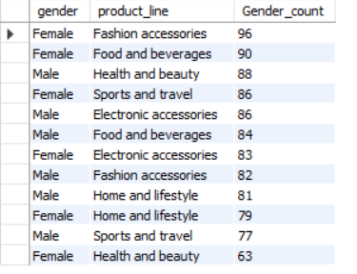

Q) What is the Average rating of each product line ?

SELECT

product_line, AVG(rating) AS Avg_rating

FROM

sales

GROUP BY product_line;

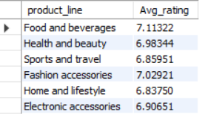

# Sales Question

Q) Number of sales made in each time of the day per weekday ?

SELECT

time_of_day, COUNT(invoice_id) AS sales_count

FROM

sales

WHERE day_name = 'Sunday'

GROUP BY time_of_day

ORDER BY sales_count DESC;

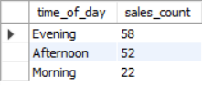

Q) Which of the Customer types bring the most revenue ?

SELECT

customer_type, SUM(total) AS revenue

FROM

sales

GROUP BY customer_type

ORDER BY Revenue DESC

LIMIT 1;



Q) Which city has the largest tax percentage / VAT (Value Added Tax) ?

SELECT

city, AVG(VAT) AS tax_percentage

FROM

sales

GROUP BY city

ORDER BY tax_percentage DESC

LIMIT 1;



Q) Which customer type pays the most in VAT ?

SELECT

customer_type, SUM(VAT) AS total_vat

FROM

sales

GROUP BY customer_type

ORDER BY total_vat DESC

LIMIT 1;



# Customer Questions

Q) How many the unique customer types does the data have ?

SELECT

COUNT(DISTINCT customer_type) AS cust_type_cnt

FROM

sales;



Q) How Many unique payment methods does the data have ?

SELECT

COUNT(DISTINCT payment_method) cnt_of_unique_method

FROM

sales;



Q) Which Customer types buys the most ?

SELECT

customer_type, SUM(total) AS total_sales

FROM

sales

GROUP BY customer_type

ORDER BY total_sales DESC

LIMIT 1;



Q) What is the gender of most of the customer ?

SELECT

gender, COUNT(*) AS count_by_gen

FROM

sales

GROUP BY gender

ORDER BY count_by_gen DESC;

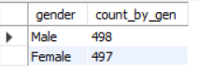

Q) What is the gender distribution per branch ?

SELECT

branch, gender, COUNT(*) AS gender_count

FROM

sales

GROUP BY gender , branch

ORDER BY branch;

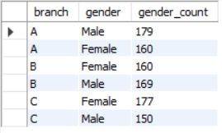

Q) Which time of the day do customer give most rating ?

SELECT

time_of_day, COUNT(rating) AS rating_count

FROM

sales

GROUP BY time_of_day

ORDER BY rating_count DESC

LIMIT 1;



Q) Which time of the day do customer give most rating per branch ?

SELECT

branch, time_of_day, COUNT(rating) AS rating_count

FROM

sales

GROUP BY branch , time_of_day

ORDER BY branch , rating_count;

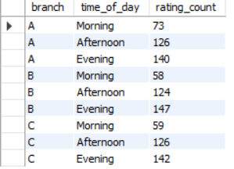

Q) Which day of the week has the best avg rating ?

SELECT

day_name, AVG(rating) AS avg_rating

FROM

sales

GROUP BY day_name

ORDER BY avg_rating DESC;

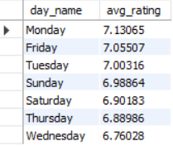

Q) Which day of the week has the best average rating per branch ?

SELECT

branch,

DAYNAME(`date`),

AVG(rating) AS avg_rating,

WEEKDAY(`date`) AS Day_num

FROM

sales

GROUP BY branch , DAYNAME(`date`) , WEEKDAY(`date`)

ORDER BY branch , WEEKDAY(`date`);

